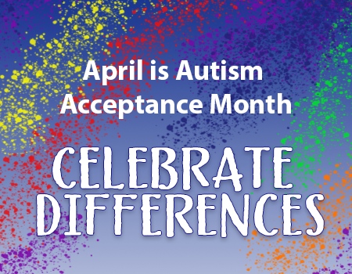
Autism Acceptance Month
Expand your reading horizon and check out some books to promote Autism Acceptance
Book suggestions from Sun Prairie Public Library

Young readers:
It Was Supposed to Be Sunny by Samantha Cotterill
Remarkable Remy by Melanie Heyworth
Masterpiece: An Inclusive Kids Book Celebrating A Child
On The Autism Spectrum by Alexandra Hoffman

Middle Grade:
The Fire, the Water and Maudie McGinn by Sally J. Pla
Like a Charm by Ellie McNicoll
We Could be Heroes by Finnegan, Margaret Mary
Bad Best Friend by Vail, Rachel

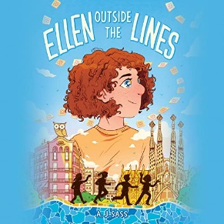

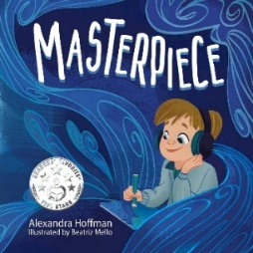
Teen:
The Secret Life of Kitty Granger by G. D. Falksen
This is the Way the World Ends by Jen Wilde
Ellen Outside the Lines by A. J. Sass



Children’s Resource Centers (CRCs) are working together with partners in the Wisconsin Wayfinder Resource Network to guide families to support and resources. CRCs can be reached through 1-877-WiscWay. You can reach CRC-South at 1-800-532-3321 or crcsouth@waisman.wisc.edu.


Dedicated to improving the lives of all who are impacted by autism by providing information, resources and support, while raising awareness and acceptance in our community.
South Central -- Website: autismsouthcentral.org
Southeastern -- Website: assew.org
Greater -- Website: autismgreaterwi.org

